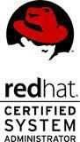
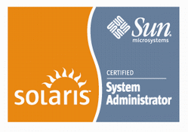
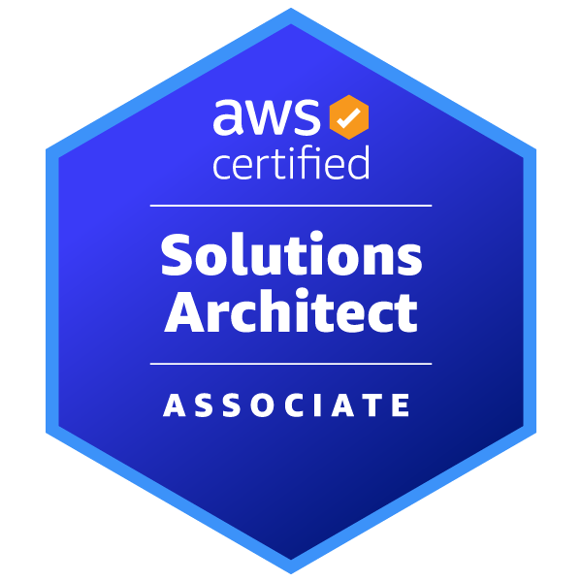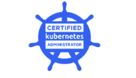

Praveen Nandale

PROFESSIONAL SUMMARY

Highly motivated and performance driven DevOps engineer with 16+ years of experience in designing, implementing, and managing complex infrastructures. Proficient in multiple DevOps tools and techniques and knowledgeable in infrastructure automation and configuration management. Demonstrated success spearheading huge implementation projects and tech support.

TECHNICAL SKILLS

Versioning Tools | Git, Git hub |  | Operating system | Linux, Unix, Windows,
Automation tools | Terraform |  | Monitoring Tool | App dynamics, Grafana, Splunk
C I Tools | Jenkins, Chef, Puppet, Ansible |  | Bug Tracking | JIRA, Service Now, Remedy
Build Tools | Maven, Gradle, Packer |  | Language | Shell, Python, SQL, NO SQL
Containerization Tool | Docker, Kubernetes |  | Database | Oracle, SQL Server, MySQL, Cassandra
Cyber security tools | IBM Qradar, Azue Sentinel ,CyberARK |  | Load Balancing | Haproxy, Nginx, F5
Web server | Apache, Tomcat |  | Cloud Services | AWS, Open stack,

PROFESSIONAL CERTIFICATIONS:

- ITIL V3 certified from Cognizant
- Comp TIA Security + Certified
- Certified AWS Solution architect
- Certified Kubernetes Administrator
- Certified VM Ware Associate – Cloud
- Certified VM Ware Associate – Data Centre Virtualization
- Certified Red Hat Certified System Administrator (RHEL 6.0)
- Sun Certified System Administrator (SUN Solaris 10 Operating Environment)

EDUCATION:

Course | Year of Pass out
Masters in Computer Application | 2004 - 2007
Bachelor in Commerce (Computer Applications) | 2000 - 2003
Intermediate School of Education | 1998 – 2000
Secondary School of Education | 1988 - 1980

WORK EXPERIENCE:

Organization | Client | Role | Year
Infosys Ltd, USA. | Comcast Corporation Inc  USA | Lead Consultant,  Dev Ops Engineer | Sept 2019 to Till Date
Cognizant Technology Solutions, USA | Comcast Corporation Inc  USA | Associate Manager,  Dev Ops Engineer | Feb 2016 to Aug 2019
Cognizant Technology Solutions, Singapore | UBSAG  Singapore | Senior Associate,  Unix Engineer | Jan 2010 to Jan 2016
UBS India Pvt Ltd, Hyderabad, India | UBS  India | Associate,  Unix Administrator | Sep 2007 to Jan 2010

SOFT SKILLS:

- Excellent Team player and leadership skills
- Strong Communication, co-ordination, and collaboration skills
- Excellent problem solving, technical acumen and documentation skills.
- Superior people management, conflict management and relationship management skills.

PROFESSIONAL SUMMARY:
Infosys Ltd, USA. Sept 2019 to Till Date
Client: Comcast Corporation Inc USA Dev Ops Lead

- Lead and mentor the team of 15 engineers, provide guidance and trouble shoot for P1, conduct RCA and other critical support
- Built, established and leading infrastructure support activities for 40+ million users through email work flow, automation, and troubleshooting
- To Spearhead projects of hardware upgrades, server configurations, Patching, vulnerability management and other infra-critical activities.
- To conduct due diligence, create processes and work on continues process improvement for server monitoring by creating playbooks using Ansible, in Splunk, App Dynamics.
- To Work on Galera DB. clustering with multiple nodes of MySQL for failover and replication as well as implementing incremental and full backups.
- Repository management, through GitHub, svn and webhooks to update repo and trigger the Jenkins play.
- Handling Access management on Cyber Ark platform.
- Installation & configuration of Cyber Ark Components (i.e. Vault, Private Ark Client, CPM, PVWA, etc.)
- Managing Single Sign On solutions for any new applications.
Cognizant Technology Solutions, USA. Feb 2016 to Aug 2019
Client: Comcast Corporation Inc. USA Lead Dev Ops Engineer

- To design, build and automate cloud infrastructure on Open stack platform, AWS cloud using Terraform
- Create, automate, and monitor build and release for application teams
- Infrastructure migration, autoscaling, monitoring and server provisioning via automation
- Lead Production support team, Incident, and problem management, conduct RCAs for management reporting
- Devops tools: Ansible, concourse,Jenkins,Terraform
- Cloud Services: EC2, VPC, Cloud watch
Cognizant Technology Solutions, USA. Jan 2010 to Jan 2016
Client: UBS AG Singapore Senior Unix Engineer

- To lead and manage and support Key Infrastructure activities like IWE, migrations, managing downtimes, server patching, cert updates, Vendor support, etc.
- Responsible for UNIX Break-fix activities and Change Hygiene across UNIX Service Delivery, along unix incidents and problem management.
- Responsible for regular Server health checks, system installations, patching, firmware upgrades for environment stability
- Collaborate with application owners, database team, storage team, network team, hardware team, and other teams as when required to resolve issues via incident channels.
- To handle Vendor management and co-ordination with global Infrastructure for diagnosis and replacement of faulty hardware.
- Network administration, Unix support through Chat channels, backup restorations and cluster management.
- Handson on Sun Volume Manager, Linux Volume Manager and Veritas Volume Manager.
- Supporting DC migration projects. Failover and Failback testing of various servers and storages.
UBS India Pvt Ltd. Sep 2007 to Jan 2010
Client: UBS AG Singapore Associate Unix Engineer

- L1 and L2 Support for Market Data Application
- Remote support to Branch IT infrastructure in Switzerland & America using BMC Patrol.
- Perform net backup restores, server and DNS administration, application support, troubleshoot power broker problems,
- To conduct daily health checks, configuration management, application deployment support, manage automated jobs
- Incident management, trouble shooting, support problem management team.

